**http client factory**

Inset the http client factory inside the program file before var app = builder.Build();

// Registering the HttpClient for making API calls

builder.Services.AddHttpClient();

**Methods**

ReadFromJsonAsync<T>() **and** ReadAsStringAsync()

Agar **aapko JSON response ko directly object me convert karna hai**, to use:

👉 ReadFromJsonAsync<T>() (easy & clean)

Agar aap **manually string parse karna chahte ho**, to use:

👉 ReadAsStringAsync() (flexible but more work)

📌 ReadFromJsonAsync<T>() – Easy and Clean

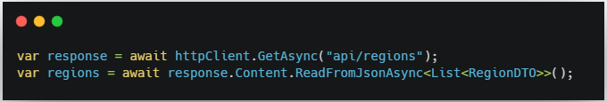

☑️ Auto JSON deserialization  
☑️ Less code  
☑️ Safe & readable

📌 ReadAsStringAsync() – Manual Parsing

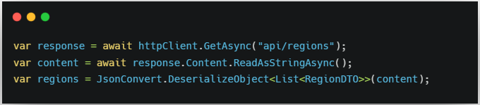

☑️ More control (e.g., logging raw JSON)  
☑️ Useful if API doesn't return clean JSON